Scheduled |  | Twitter |  | Images
 | 🌞 Welcome to Family Learning  Who are Family Learning? What do they do? Want to know more?  😄 This fantastic FREE online session is an opportunity to find out about Family Learning. Join them for themed activities, meet the team and discover what they do.  With the support of their dedicated tutor, you will learn about our offer and how you can take part in the range of online and face-to-face opportunities available.  This online session is suitable for those with children aged 0-7 years with their children, taking part together.  We welcome SEND families.  Find out more and book your place ⬇️  https://www.norfolk.gov.uk/familylearning | 🌞 Who are Family Learning? What do they do? Want to know more?  😄 Join @Norfolklearn for their fantastic FREE online Welcome to Family Learning session & find out about their courses & services  Find out more and book your place ⬇️  https://www.norfolk.gov.uk/familylearning | 🌞 Welcome to Family Learning  Who are Family Learning? What do they do? Want to know more?  😄 This fantastic FREE online session is an opportunity to find out about Family Learning. Join them for themed activities, meet the team and discover what they do.  With the support of their dedicated tutor, you will learn about our offer and how you can take part in the range of online and face-to-face opportunities available.  This online session is suitable for those with children aged 0-7 years with their children, taking part together.  We welcome SEND families.  Head to the link in their bio to find out more and book your place or search ⬇️  www.norfolk.gov.uk/familylearning  #Norfolk | 
 | 🥦 Does your child bemoan broccoli and snub sweet potato?  🥗 Join Norfolk Adult Learning’s fantastic FREE Fussy Eaters session and with the support of their dedicated tutor, you will gain confidence and skills to encourage your child to eat a healthy, balanced diet.  This session is designed for parents/carers and their children aged 0 to 4 years, taking part together.  11th Feb  Find out more and book your place ⬇️  https://www.norfolk.gov.uk/familylearning | 🥦 Does your child bemoan broccoli and snub sweet potato?  🥗 Join @Norfolklearn fantastic FREE Fussy Eaters session and with the support of their dedicated tutor, you will gain confidence and skills to encourage your child to eat a healthy, balanced diet. This session is designed for parents/carers and their children aged 0 to 4 years, taking part together.  11th Feb  Find out more and book your place ⬇️  https://www.norfolk.gov.uk/familylearning | 🥦 Does your child bemoan broccoli and snub sweet potato?  🥗 Join the fantastic @norfolk_adult_learning FREE Fussy Eaters session and with the support of their dedicated tutor, you will gain confidence and skills to encourage your child to eat a healthy, balanced diet. This session is designed for parents/carers and their children aged 0 to 4 years, taking part together.  11th Feb  Head to the link in their bio to find out more and book your place or search ⬇️  www.norfolk.gov.uk/familylearning  #Norfolk | 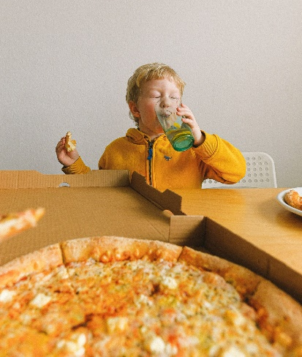
 | 🧮 How confident do you feel supporting your children with maths?  🔲 Do you know what a 100 square is and how it's used in schools?  ➕Join Norfolk Adult Learning for their fantastic FREE 90-minute online session which will help you discover some fun maths-based activities from the comfort of your own home.  😄 With the support of their dedicated tutor, you will also learn how you children are taught in school and how you can best support this learning at home focussed on 100 squares.  This course is for any adult over the age of 19 who has responsibility for the care of a child or children aged 4 to 7.  📅 31st Jan 2022  💻 Online  Find out more and book your place ⬇️  https://www.norfolk.gov.uk/familylearning | 🧮 How confident do you feel supporting your children with maths?  ➕Join @Norfolklearn for their fantastic FREE online session & discover fun maths-based activities  Find out more & book your place ⬇️  https://www.norfolk.gov.uk/familylearning #Norfolk | 🧮 How confident do you feel supporting your children with maths?  🔲 Do you know what a 100 square is and how it's used in schools?  ➕Join norfolk_adult_learning for their fantastic FREE 90-minute online session which will help you discover some fun maths-based activities from the comfort of your own home.  😄 With the support of their dedicated tutor, you will also learn how you children are taught in school and how you can best support this learning at home focussed on 100 squares.  This course is for any adult over the age of 19 who has responsibility for the care of a child or children aged 4 to 7.  📅 31st Jan 2022  💻 Online  Head to the link in their bio to find out more and book your place or search ⬇️  www.norfolk.gov.uk/familylearning  #Norfolk | 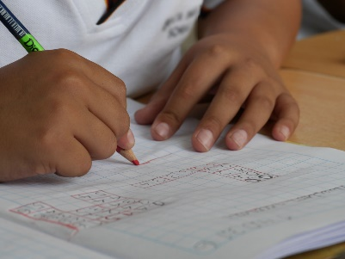
 | 🧮 How confident do you feel supporting your children with KS2 maths?  😕 Maybe what they learn at school is confusing you? Join Norfolk Adult Learning’s fantastic FREE 90-minute online session which will help you discover some fun maths-based activities from the comfort of your own home.  This course is for any adult over the age of 19 who has responsibility for the care of a child or children aged 4 to 7.  📅 Feb 7th 2022  💻 Online  Find out more and book your place ⬇️  https://www.norfolk.gov.uk/familylearning | 🧮 How confident do you feel supporting your children with KS2 maths?  😕 Maybe what they learn at school is confusing you? Join @Norfolklearn fantastic FREE online session on Feb 7th & discover fun maths-based activities  Find out more & book your place ⬇️  https://www.norfolk.gov.uk/familylearning #Norfolk | 🧮 How confident do you feel supporting your children with KS2 maths?  😕 Maybe what they learn at school is confusing you? Join Norfolk Adult Learning’s fantastic FREE 90-minute online session which will help you discover some fun maths-based activities from the comfort of your own home.  This course is for any adult over the age of 19 who has responsibility for the care of a child or children aged 4 to 7.  📅 Feb 7th 2022  💻 Online  Head to the link in their bio to find out more and book your place or search ⬇️  www.norfolk.gov.uk/familylearning  #Norfolk | 
 | 😷 Was your baby/child born during or around the start of Covid-19?  🏡 Norfolk Adult Learning’s fantastic FREE online session is an opportunity to explore the impact of the pandemic and lockdowns on children born during this unique period. With the support of their dedicated tutor, you will discover the impact of Covid-19 on early attachment and self-regulation and consider how to support your child's transition as they settle into their early years setting.  👶 This session is suitable for those with children aged 0-3 years. Parents/carers are encouraged to attend without their children. We welcome SEND families.  📅 4th Feb 2022  💻 Online  Find out more and book your place ⬇️  https://www.norfolk.gov.uk/familylearning | 😷 Was your child born during or around the start of Covid-19?  Join @Norfolklearn & discover the impact of the pandemic on early attachment & self-regulation & how to support your child's transition into their early years setting  Find out more & book your place ⬇️  https://www.norfolk.gov.uk/familylearning #Norfolk | nb | 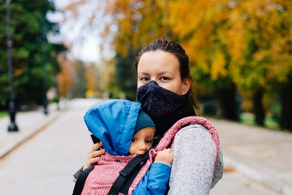
 | 🧪 Are you looking for new ways to support your child’s KS2 science development?  🧒 Do they have an interest in art?  Join Norfolk Adult Learning for their fantastic FREE online session provides opportunities for you to discover a range of art and craft activities, which can be used to support and enhance children’s science development. Making the most of resources you find around the house, these activities will be themed around science and nature to get them thinking not only about their art, but also scientific vocabulary.  20th Jan  Find out more and book your place ⬇️  https://www.norfolk.gov.uk/familylearning | 🧪 Are you looking for new ways to support your child’s KS2 science development?  🎨 Join @Norfolklearn & discover a range of art activities, which can be used to support & enhance children’s science  Online 20th Jan  Find out more ⬇️  https://www.norfolk.gov.uk/familylearning | 🧪 Are you looking for new ways to support your child’s KS2 science development? Do they have an interest in art?  🧒 Join @norfolk_adult_learning for their fantastic FREE online session provides opportunities for you to discover a range of art and craft activities, which can be used to support and enhance children’s science development. Making the most of resources you find around the house, these activities will be themed around science and nature to get them thinking not only about their art, but also scientific vocabulary.  20th Jan  Head to the link in their bio to find out more and book your place or search ⬇️  www.norfolk.gov.uk/familylearning  #Norfolk | 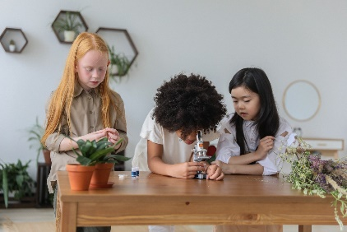
 | 🧪 Are you looking for new ways to support your child’s KS1 science development? Do they have an interest in art?  🧒 Join Norfolk Adult Learning’s fantastic FREE online session which provides opportunities for you to discover a range of art and craft activities, which can be used to support and enhance children’s science development. Making the most of resources you find around the house, these activities will be themed around science and nature to get them thinking not only about their art, but also scientific vocabulary.  19th Jan  Find out more and book your place ⬇️  https://www.norfolk.gov.uk/familylearning | 🧪 Are you looking for new ways to support your child’s KS1 science development?  🎨 Join @Norfolklearn & discover a range of art activities, which can be used to support & enhance children’s science  Online 20th Jan  Find out more ⬇️  https://www.norfolk.gov.uk/familylearning | 🧪 Are you looking for new ways to support your child’s KS1 science development? Do they have an interest in art?  🧒 Join @norfolk_adult_learning for their fantastic FREE online session which provides opportunities for you to discover a range of art and craft activities, which can be used to support and enhance children’s science development. Making the most of resources you find around the house, these activities will be themed around science and nature to get them thinking not only about their art, but also scientific vocabulary.  19th Jan  Head to the link in their bio to find out more and book your place or search ⬇️  www.norfolk.gov.uk/familylearning  #Norfolk | 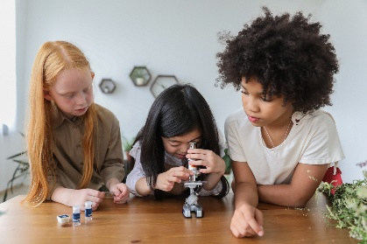
 | 🧮 Are you looking for new ways to support your child’s KS1 numeracy development?  🎨 Do they have an interest in art?  Join Norfolk Adult Learning’s fantastic FREE online session which provides opportunities for you to discover a range of art and craft activities, which can be used to support and enhance children’s maths development. Making the most of resources you find around the house, these activities will be themed around shape to get them thinking not only about their art, but also 2D and 3D shapes and mathematical vocabulary.  Jan 12 2022  Find out more and book your place ⬇️  https://www.norfolk.gov.uk/familylearning | 🧮 Are you looking for new ways to support your child’s KS1 numeracy development?  🎨 Join the fantastic @Norfolklearn FREE online session & discover a range of art activities, to support & enhance children’s maths skills  Find out more ⬇️  https://www.norfolk.gov.uk/familylearning | 🧮 Are you looking for new ways to support your child’s KS1 numeracy development?  🎨 Do they have an interest in art?  Join @norfolk_adult_learning for their fantastic FREE online session which provides opportunities for you to discover a range of art and craft activities, which can be used to support and enhance children’s maths development. Making the most of resources you find around the house, these activities will be themed around shape to get them thinking not only about their art, but also 2D and 3D shapes and mathematical vocabulary.  Jan 12 2022  Head to the link in their bio to find out more and book your place or search ⬇️  www.norfolk.gov.uk/familylearning  #Norfolk | 
 | Are you looking for new ways to support your child’s KS1 numeracy development?  🎨 Do they have an interest in art?  Join Norfolk Adult Learning’s fantastic FREE online session which provides opportunities for you to discover a range of art and craft activities, which can be used to support and enhance children’s Maths development. Making the most of resources you find around the house, these activities will be themed around shape to get them thinking not only about their art, but also 2D and 3D shapes and mathematical vocabulary.  Jan 12 2022  Find out more and book your place ⬇️  https://www.norfolk.gov.uk/familylearning | Are you looking for new ways to support your child’s KS2 numeracy development?  🎨 Join the fantastic @Norfolklearn FREE online session & discover a range of art activities, to support & enhance children’s Maths skills  Find out more ⬇️  https://www.norfolk.gov.uk/familylearning | 🧮 Are you looking for new ways to support your child’s KS1 numeracy development?  🎨 Do they have an interest in art?  Join @norfolk_adult_learning for their fantastic FREE online session which provides opportunities for you to discover a range of art and craft activities, which can be used to support and enhance children’s Maths development. Making the most of resources you find around the house, these activities will be themed around shape to get them thinking not only about their art, but also 2D and 3D shapes and mathematical vocabulary.  Jan 12 2022  Head to the link in their bio to find out more and book your place or search ⬇️  www.norfolk.gov.uk/familylearning  #Norfolk | 
 | ✍️ How confident do you feel supporting your children with KS1 English? Maybe what they learn at  school is confusing you.  📚 Join Norfolk Adult Learning for their fantastic FREE 90-minute online session which will help you  discover some fun English-based activities from the comfort of your own home. With  the support of their dedicated tutor, you will also learn how your children are taught in school and how you can best support this learning at home.  This session is for any adult over the age of 16 who has responsibility for the care of a child or  children aged 4 to 7.  17th Jan 2022  Find out more and book your place ⬇️  https://www.norfolk.gov.uk/familylearning | ✍️ How confident do you feel supporting your children with KS1 English?  📚 Join @Norfolklearn for their fantastic FREE online session which will help you  discover some fun English-based activities  24 Jan  Find out more ⬇️  https://www.norfolk.gov.uk/familylearning | ✍️ How confident do you feel supporting your children with KS2 English? Maybe what they learn at  school is confusing you.  📚 Join @norfolk_adult_learning for their fantastic FREE 90-minute online session which will help you  discover some fun English-based activities from the comfort of your own home. With  the support of their dedicated tutor, you will also learn how your children are taught in school and how you can best support this learning at home.  This session is for any adult over the age of 16 who has responsibility for the care of a child or  children aged 4 to 7.  24th Jan 2022  Head to the link in their bio to find out more and book your place or search ⬇️  www.norfolk.gov.uk/familylearning  #Norfolk | 
 | ✍️ How confident do you feel supporting your children with KS2 English? Maybe what they learn at  school is confusing you.  📚 Join Norfolk Adult Learning for their fantastic FREE 90-minute online session which will help you  discover some fun English-based activities from the comfort of your own home. With  the support of their dedicated tutor, you will also learn how your children are taught in school and how you can best support this learning at home.  This session is for any adult over the age of 16 who has responsibility for the care of a child or  children aged 4 to 7.  24th Jan 2022  Find out more and book your place ⬇️  https://www.norfolk.gov.uk/familylearning | ✍️ How confident do you feel supporting your children with KS2 English?  📚 Join @Norfolklearn for their fantastic FREE online session which will help you  discover some fun English-based activities  24 Jan  Find out more ⬇️  https://www.norfolk.gov.uk/familylearning | ✍️ How confident do you feel supporting your children with KS2 English? Maybe what they learn at  school is confusing you.  📚 Join @norfolk_adult_learning for their fantastic FREE 90-minute online session which will help you  discover some fun English-based activities from the comfort of your own home. With  the support of their dedicated tutor, you will also learn how your children are taught in school and how you can best support this learning at home.  This session is for any adult over the age of 16 who has responsibility for the care of a child or  children aged 4 to 7.  24th Jan 2022  Head to the link in their bio to find out more and book your place or search ⬇️  www.norfolk.gov.uk/familylearning  #Norfolk | 
 | 🩹 Paediatric First Aid ONLINE  🧒 This could be the most valuable 2 hours of ONLINE learning you have ever spent. Choking, head injury and fracture all are medical emergencies that children may experience. Do you know how to respond? This fantastic FREE paediatric first aid workshop will give you the knowledge and skills to make a difference and potentially save a life.  Find out more and book your place ⬇️  https://www.norfolk.gov.uk/familylearning | 🩹 Do you work with young children? Join the @Norfolklearn online Paediatric First Aid course  🧒 This could be the most valuable 2 hours of learning you have ever spent  Find out more & book your place ⬇️  https://www.norfolk.gov.uk/familylearning | 🩹 Do you work with young children?  Join @norfolk_adult_learning for their online Paediatric First Aid course  🧒 This could be the most valuable 2 hours of learning you have ever spent. Choking, head injury and fracture all are medical emergencies that children may experience. Do you know how to respond? This fantastic FREE paediatric first aid workshop will give you the knowledge and skills to make a difference and potentially save a life.  Head to the link in their bio to find out more and book your place or search ⬇️  www.norfolk.gov.uk/familylearning  #Norfolk | 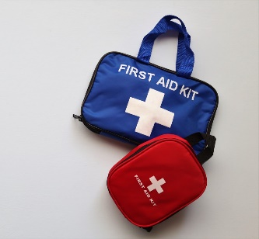
 | 🩹 Do you work with young children?  Join Norfolk Adult Learning for their Paediatric First Aid course  🧒 This could be the most valuable 2 hours of learning you have ever spent. Choking, head injury and fracture all are medical emergencies that children may experience. Do you know how to respond? This fantastic FREE paediatric first aid workshop will give you the knowledge and skills to make a difference and potentially save a life.  Find out more and book your place ⬇️  https://www.norfolk.gov.uk/familylearning | 🩹 Do you work with young children? Join the @Norfolklearn Paediatric First Aid course  🧒 This could be the most valuable 2 hours of learning you have ever spent  Find out more & book your place ⬇️  https://www.norfolk.gov.uk/familylearning | 🩹 Do you work with young children?  Join @norfolk_adult_learning for their Paediatric First Aid course  🧒 This could be the most valuable 2 hours of learning you have ever spent. Choking, head injury and fracture all are medical emergencies that children may experience. Do you know how to respond? This fantastic FREE paediatric first aid workshop will give you the knowledge and skills to make a difference and potentially save a life.  Head to the link in their bio to find out more and book your place or search ⬇️  www.norfolk.gov.uk/familylearning  #Norfolk | 